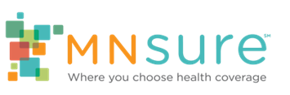

Communications Toolkit for Brokers

Toolkit Purpose
MNsure has created a set of communications materials for brokers to use during the “unwinding” of federal continuous coverage requirements.
MNsure and the Minnesota Department of Human Services (DHS) are working together to help current public health care program enrollees complete the eligibility renewal process and avoid any gaps in coverage. DHS’ enrollee-facing materials (available online) encourage Medical Assistance and MinnesotaCare enrollees to update their contact information, look for their health insurance renewal in the mail, and fill out and return the requested materials by the deadline.
MNsure’s enrollee-facing materials focus on what to do next when enrollees return their renewal and find out they’re no longer eligible for Medical Assistance or MinnesotaCare and are newly eligible to buy private health insurance (qualified health plan or QHP).
Over the next year, brokers will play a crucial role in helping these newly QHP-eligible Minnesotans transition to private health plans. Many may have little or no previous experience with QHPs and could use personalized assistance choosing a plan that fits their needs and budget.

Communications for Brokers to Share

E-mail message or newsletter
Subject line: Finding new coverage if you’re no longer eligible for Medical Assistance or MinnesotaCare
If you have Medical Assistance or MinnesotaCare, watch your mail for important information from the Department of Human Services about how to renew your coverage. Make sure to return the requested materials by the deadline.
After you submit your renewal, you may find out you are no longer eligible for Medical Assistance or MinnesotaCare coverage. You may be eligible to buy private health insurance – and get financial help to lower the cost – through MNsure, Minnesota’s official health insurance marketplace.
[Agency Name] can help you understand your options and find new coverage, so you can keep getting the care you need. Our MNsure-certified brokers offer free help choosing a private plan that fits your needs and your budget. Get in touch with us at [insert calls to action] or visit mnsure.org/newcoverage to learn more.

QR Code
Include this QR code in any context or design project where you want to drive consumers to the MNsure webpage. Always include the URL (mnsure.org/newcoverage) close to the QR code.
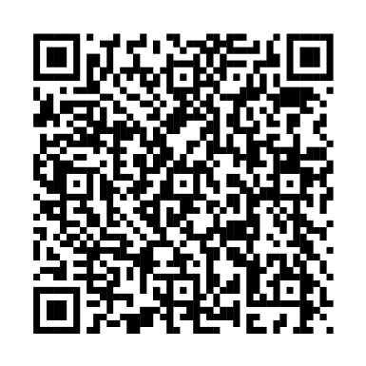

Social Media Posts
Images | Copy
 | If you’re no longer eligible for Medical Assistance or MinnesotaCare, [Agency Name] can help you make a smooth transition to a private health plan that fits your needs and budget. Connect with us for help at [insert calls to action] or visit mnsure.org/newcoverage to learn more.
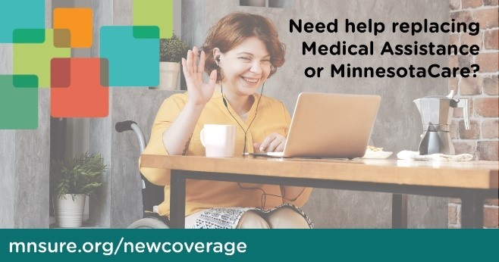 | No longer eligible for Medical Assistance or MinnesotaCare? [Agency Name] can help you understand your options and find the private health plan that’s right for you. We offer FREE help in person, over the phone, or by virtual meeting. Get in touch with us at [insert calls to action].
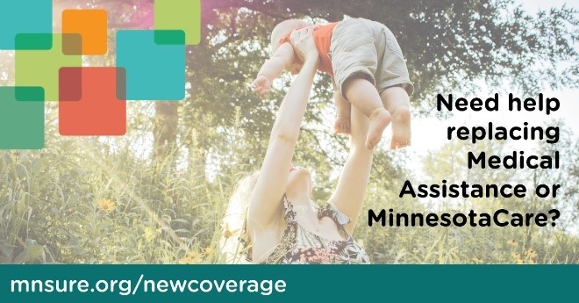 | If you’re no longer eligible for Medical Assistance or MinnesotaCare, [Agency Name] can help you find new coverage. You may be eligible to buy a private health plan – and get financial help to lower the cost – through MNsure. Connect with us for help at [insert calls to action] or visit mnsure.org/newcoverage.

