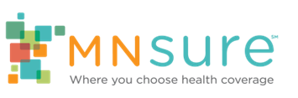

Evergreen Posts

Facebook
Assisters are available year-round to help Minnesotans! We can help with @MNsure special enrollment and MinnesotaCare & Medical Assistance enrollment, as well as answering general questions. Give us a call at [PHONE #] or visit our website: [LINK]
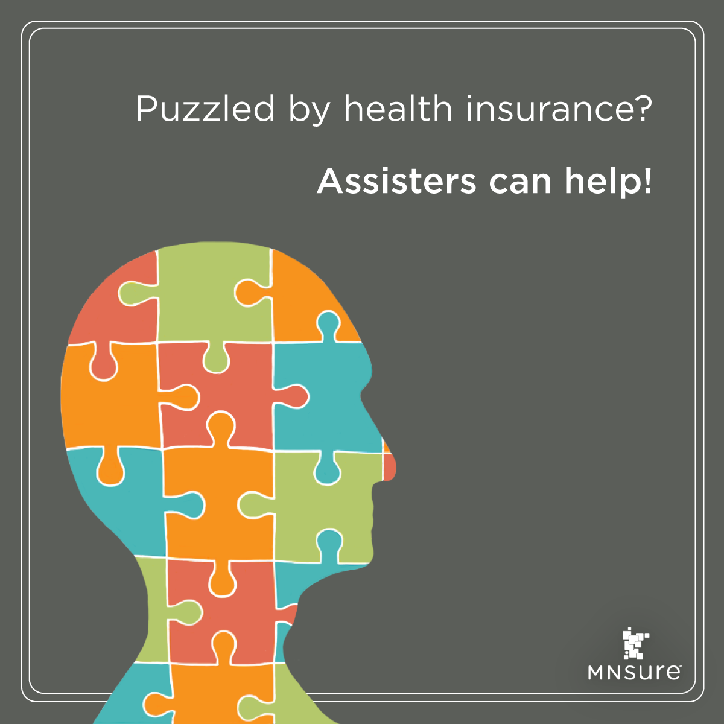
Not sure where to start with the application process? Not sure what some of those health insurance terms mean? Need help choosing a plan that is best for you and your family?
We can help! Call us at [PHONE #]
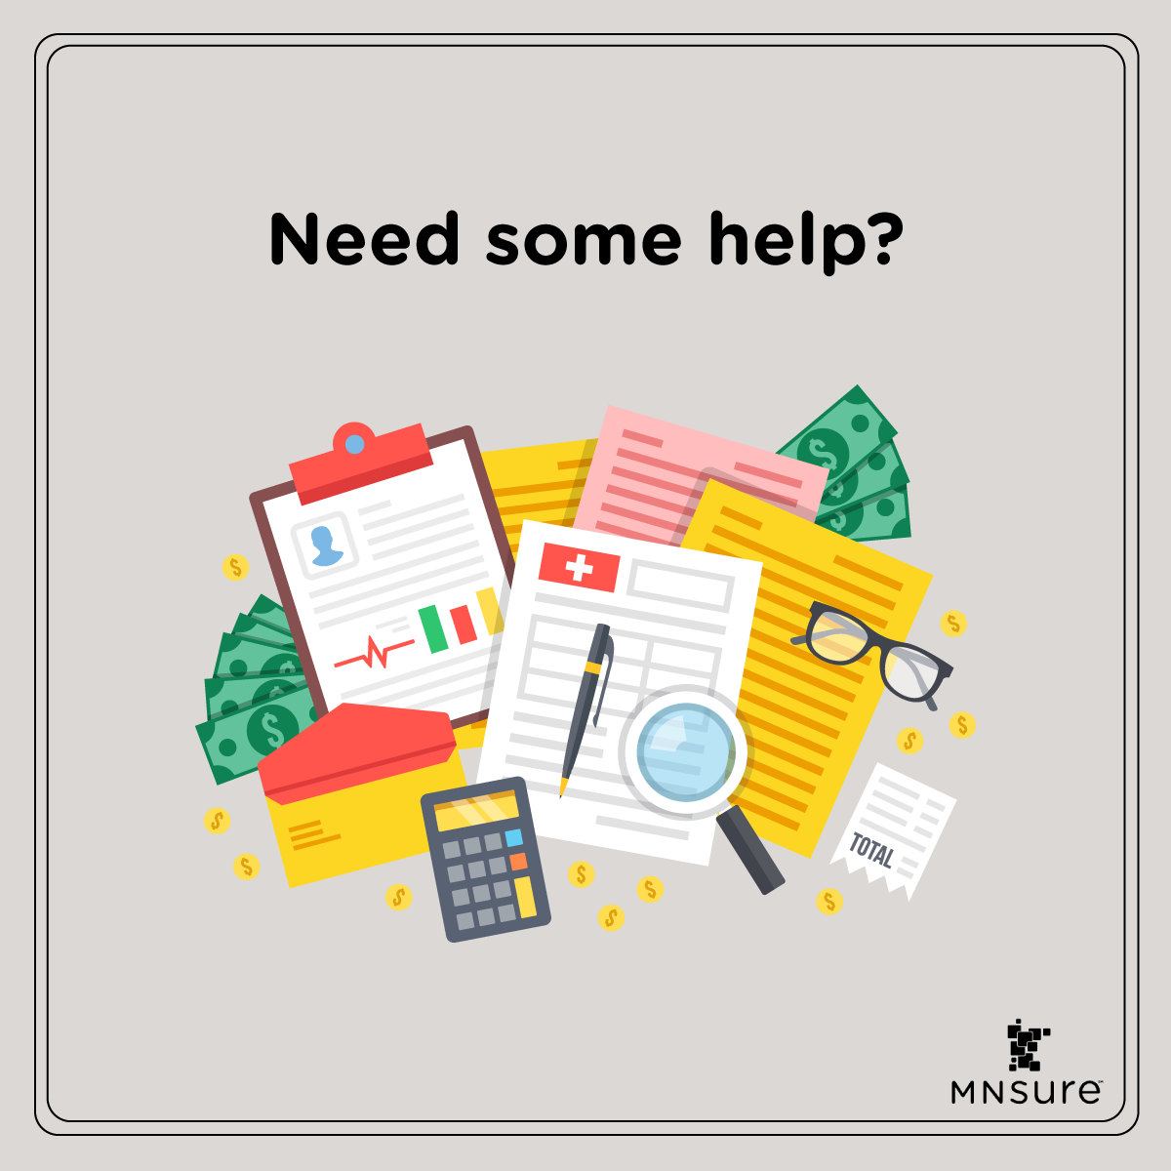
Navigators and brokers (like us!) are available around the state to help you make the right decision for you and your family about your health insurance. We can help you apply through MNsure, whether you qualify for private coverage, MinnesotaCare, or Medical Assistance. Reach out if you need help: [PHONE #]
We can help you apply and enroll through MNsure.org year-round. We’re available to provide free over-the-phone help for Minnesotans who qualify for special enrollments or public health programs (MinnesotaCare and Medical Assistance). Give us a call at: [PHONE #]
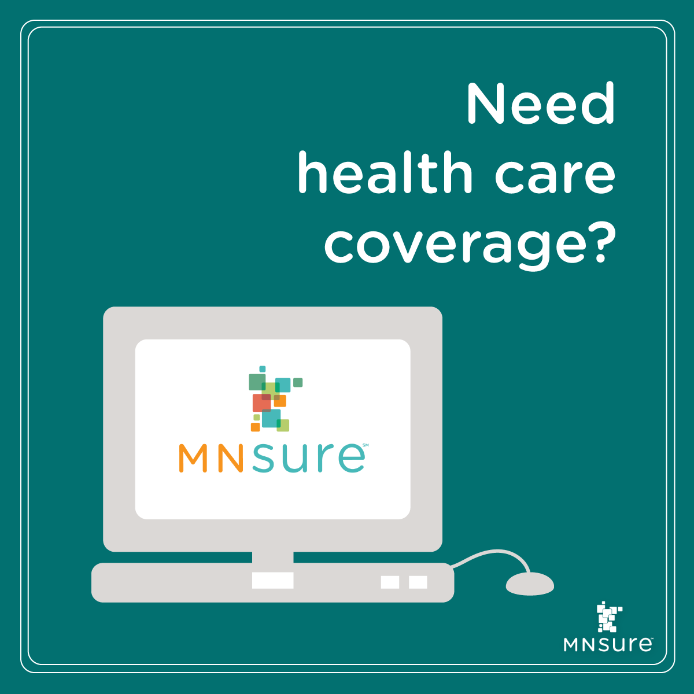
You may be able to enroll in health coverage, even outside of MNsure’s open enrollment period. See if you may qualify for a special enrollment period (http://bit.ly/MNsureSEP) or MinnesotaCare/Medical Assistance (http://bit.ly/IncGuidelines). We’re happy to help you through this process: [PHONE #]
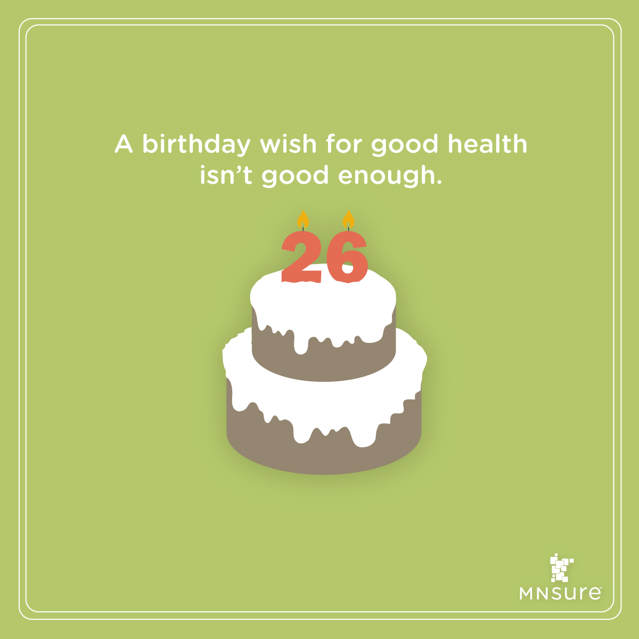
Are you 25 & on your parents' insurance plan? Turning 26 may qualify you for special enrollment through @MNsure! http://bit.ly/MNsureSEP
We’re happy to help you apply & enroll! [PHONE #]

You may qualify for a special enrollment period (SEP) through MNsure if you lost or will lose health coverage. Give us a call at [PHONE #] for help getting covered!
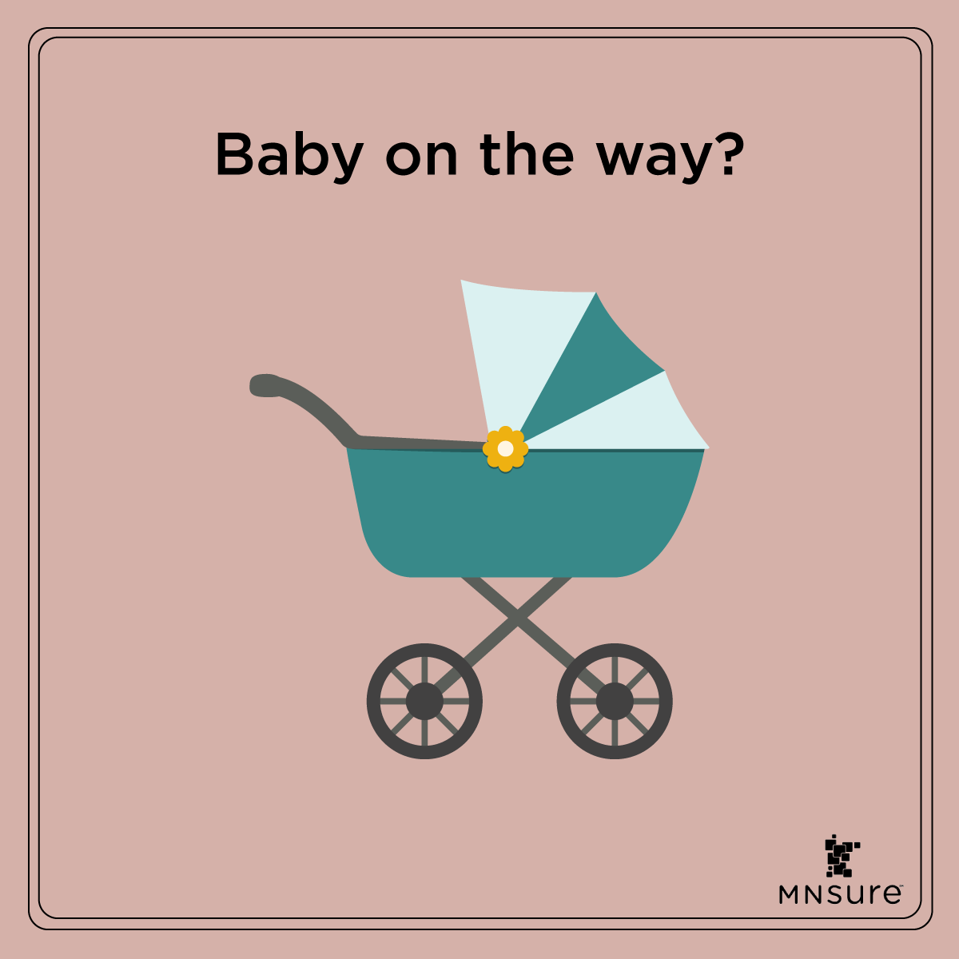
Life continues to happen, even in these unusual times. If you or your spouse had a baby recently, your household may qualify for special enrollment through MNsure! We can help you enroll in the coverage you & your new family need: [PHONE #]
Weddings may look a little different these days but getting married still means you may qualify for special enrollment through MNsure.org. We’d be happy to help you & your new spouse get the coverage you need to stay healthy! [PHONE #]
Current MNsure consumers: Changes in household income can affect your eligibility for coverage or financial assistance. We can help you keep your account up-to-date and make sure you’re getting the right coverage. Give us a call!

Twitter
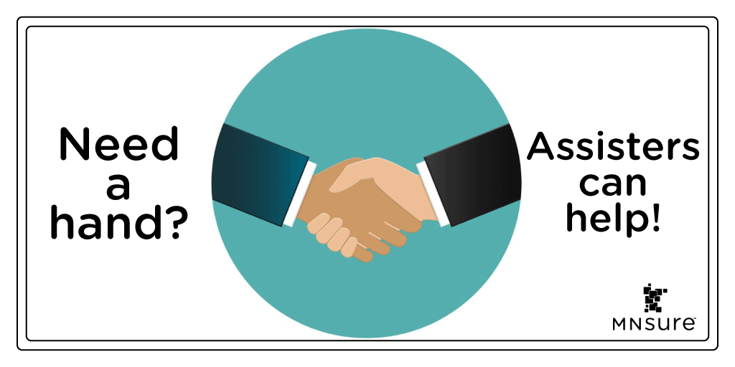
We’re available year-round to help Minnesotans! We can help you enroll in a private health plan through @MNsure or enroll in MinnesotaCare/Medical Assistance. Give us a call at [PHONE #] or visit our website: [LINK]
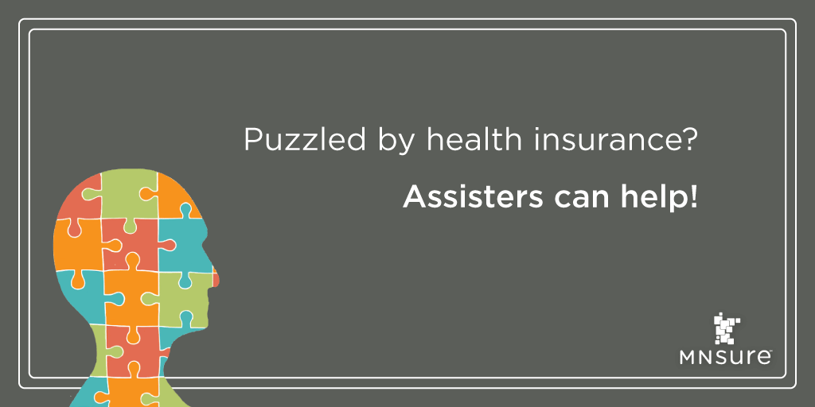
Not sure where to start with the application process? Not confident what some of those health insurance terms mean? Need help choosing a plan through @MNsure that is best for you and your family?
We can help! Call us at [PHONE #]

Assisters (like us!) are available to help you make the right decision your health insurance. We can help you apply through @MNsure, whether you qualify for private coverage, MinnesotaCare, or Medical Assistance. Reach out if you need help: [PHONE #]
We’re available to provide free over-the-phone help for Minnesotans who qualify for @MNsure special enrollments or @MinnesotaDHS public health programs (MinnesotaCare and Medical Assistance). Give us a call at: [PHONE #]
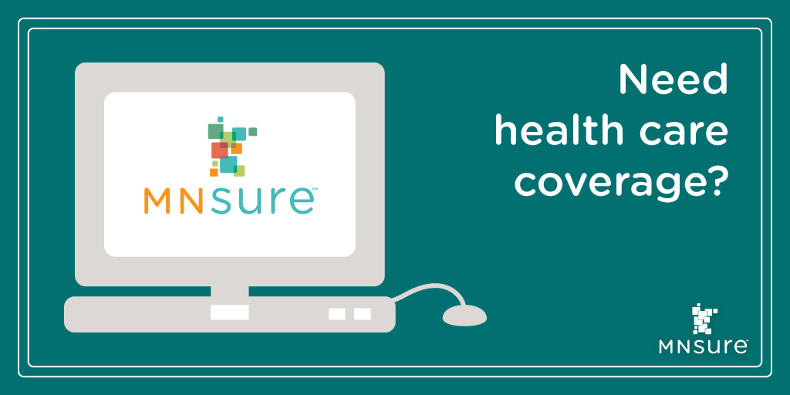
You may be able to enroll in health coverage, even outside of @MNsure’s open enrollment. See if you may qualify (http://bit.ly/MNsureSEP. (MA & MCRE have year-round enrollment!) We’re happy to help you through this process: [PHONE #]
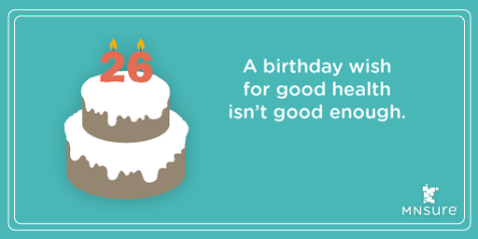
Are you 25 & on your parents' insurance plan? Turning 26 may qualify you for special enrollment through @MNsure! http://bit.ly/MNsureSEP
We’re happy to help you apply & enroll! [PHONE #]
You may qualify for a special enrollment period (SEP) through @MNsure if you lost or will lose health coverage. Give us a call at [PHONE #] for help getting covered!
Current MNsure consumers: Changes in household income can affect your eligibility for coverage or financial assistance. We can help you keep your account up-to-date and make sure you’re getting the right coverage. Give us a call!

Instagram
Assisters are available year-round to help Minnesotans! We can help with @MNsure special enrollment and MinnesotaCare & Medical Assistance enrollment, as well as answering general questions. Give us a call at [PHONE #]

Not sure where to start with the application process? Not sure what some of those health insurance terms mean? Need help choosing a plan that is best for you and your family?
We can help! Call us at [PHONE #]
Navigators and brokers (like us!) are available around the state to help you make the right decision for you and your family about your health insurance. We can help you apply through @MNsureorg, whether you qualify for private coverage, MinnesotaCare, or Medical Assistance. Reach out if you need help: [PHONE #]
We’re here to help you apply and enroll through @MNsureorg year-round. We’re can provide free over-the-phone help for Minnesotans who qualify for special enrollments or public health programs (MinnesotaCare/Medical Assistance). Give us a call at: [PHONE #]
You may be able to enroll in health coverage, even outside of MNsure’s open enrollment period. See if you may qualify for a special enrollment period or MinnesotaCare/Medical Assistance at @MNsureorg. We’re happy to help you through this process: [PHONE #]
You may qualify for a special enrollment period (SEP) through @MNsureorg if you lost or will lose health coverage. Give us a call at [PHONE #] for help getting covered!
Are you 25 & on your parents' insurance plan? Turning 26 may qualify you for special enrollment through @MNsureorg!
We’re happy to help you apply & enroll! [PHONE #]
Life continues to happen, even in these unusual times. If you or your spouse had a baby recently, your household may qualify for special enrollment through MNsure! We can help you enroll in the coverage you & your new family need: [PHONE #]

Weddings may look a little different these days but getting married still means you may qualify for special enrollment through @MNsureorg. We’d be happy to help you & your new spouse get the coverage you need to stay healthy! [PHONE #]
Current MNsure consumers: Changes in household income can affect your eligibility for coverage or financial assistance. We can help you keep your account up-to-date and make sure you’re getting the right coverage. Give us a call!

