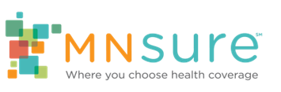

Relationship Building in MNsure Outreach
  - Tips for Creating External Partnerships
External Partnerships are the relationships we create with people or organizations outside of our own. Building effective relationships expands your capacity to find and enroll the uninsured.
Network with Assisters in your Community
Building strong relationships with other assisters will be one of the most effective ways to reach and serve those who are uninsured in your community. Connect with MNsure assisters in your community who can help you and your organization reach and enroll new consumers.
- Navigators
- Brokers
- Certified Application Counselors
- County partners

Connect with Organizations Serving Families in Need
Minnesota has a robust non-profit sector with a large network of organizations helping families and individuals meet their basic needs. Many of these organizations come into contact with people who are uninsured and face many barriers to enrolling in health insurance. Often, staff at these organizations are eager to help their clients find stable health care coverage and they may be interested in partnering with you. A few examples include:
- Food banks
- Homeless shelters
- Subsidized housing providers
- Faith communities

Reach New Audiences
In addition to families in need, there are other potential consumers in your community who may benefit from MNsure enrollment information. Some examples of where to find new audiences are:
- Employees at small businesses
- Students at community and technical colleges
- Retail workers at stores, shops and shopping malls
- Hospitality workers at restaurants, cafés and bars
- Employees at child care centers and long-term care facilities
- Seasonal employees at local resorts and tourist areas
- Clients of tax-preparers and accountants
- Farmer and lawyer associations in the area

